Computer Vision in Sports:
Player Tracking for the creation of (Game Cast)
Peyton Hollis, Curtis Canby, Uchenna Ibe

(Game cast could be another word, kinda just means a ui of live play by play action, title of what is actually being created should be changed at some point)

Abstract
Computer Vision (CV) is a subfield of artificial intelligence that enables computers and systems to derive information from images, videos, and other visual inputs allowing them to take actions and make decisions from said visual inputs. CV is an ever-growing topic within computer science with many use cases including facial recognition, object detection, medical imaging, security/surveillance, sports analytics, and more. (https://alwaysai.co/blog/computer-vision-applications) This research will focus on using CV for sports analytics, specifically player tracking. A pretrained model, will be trained on manually annotated images for player, ball, and field tracking. This model will then be utilized to create an application that visualizes real time player and ball tracking in a user friendly design.
Keywords: Computer Vision, Full Stack Development, AI training, Sports Analytics
Introduction
Computer Vision (CV) is a subfield of artificial intelligence that enables computers and systems to derive information from images, videos, and other visual inputs allowing them to take actions and make decisions from said visual inputs. In recent years, CV has seen expanding use cases including an expanding use within sports analytics. Within sports analytics, CV allows the automated extraction of meaningful information enabling insights into player movements, team tactics, and sport play tracking. The basis of extraction relies primarily on leveraging CV models for tasks including field registration, object tracking, action recognition and detection, and pose estimation. This paper will explore the most basic forms of CV tasks including field registration and player and ball tracking. It will also compare capabilities between traditional CV models, like Ultralytics YOLO and OpenCV, and modern approaches of Vision Transformer models, like Radar-Fusion Detection Transformer (RF-DETR) and Shifted Window Transformer (SWIN).
After making a determination on which type of model is best suited for this project, based on varying CV evaluation metrics including MOTA (Multi-Object Tracking Accuracy), HOTA (Higher Order Tracking Accuracy), IDF1 (ID F1 score), along with speed and real time performance capabilities, a CV model will be built and trained on soccer broadcasts to create a real time visualization of soccer sports broadcasts that users can view.
The rest of this section will explore key concepts within this project including field registration, player and ball tracking, Convolutional Neural Networks (CNN), Vision Transformers including SWIN (ViT), and varying performance metrics for CV models.
Field registration
Field registration (FR) or field tracking is an important topic within sports analytics utilizing CV. FR aims to solve many problems that arise with modern day sports broadcasting occurring due to multiple camera angles, varying image sizing, and frequent visual obstructions on the field. FR attempts to take multiple images of the same object/view taken from varying camera angles and align them on a single image. This technique aids CV models in making accurate image recognition when varying camera angles are used and there are frequent visual obstructions.
Within the context of this project, FR could be utilized to create frame persistence within video processing in locating and maintaining sport field/court landmarks. The need for using FR will be explored when training and testing the capabilities of different CV models including an Ultralytics YOLO model, a ViT model, and a SWIN model, in field landmark detection. Testing metrics will determine how viable and effective the use of FR would be in this project. FR has a large trade-off as it is often the slowest process within image recognition tasks and may be too slow for developing a real-time application.
Further research indicates that ViT models lack the need for specific FR training. ViT models break an image into larger patches rather than tokens that allows the model to use self-attention across the entire image. This increases object detection performance even with varying camera frames.
Player and Ball Tracking
Player and ball tracking will be the main priority within this project. Player tracking will require a CV model that performs well in Multi-Object Tracking (MOT). Additionally, models will be required to distinguish between players on opposing teams. This will require the model to both be good at detection as well as persistence/association.
Convolutional Neural Network (CNN) Models
Convolutional Neural Networks are a form of deep learning model which is particularly good at automatically extracting features from an image. CNN models achieve this by using convolutional layers which find local patterns through filtering and pooling layers which reduce dimensionality. This model excels at being fast and efficient compared to other models.
Vision Transformer (ViT) and Shifting Window (SWIN) Models
Vision Transformers are specifically designed for computer vision. They break an image into small sections that can be processed as matrices rather than needing to be text or tokens. The Shifting Window Model is a special type of vision transformer which allows for local and global attention. This makes it well suited for image classification and expensive tasks like object detection. It's known for being most useful at detecting fine details and scanning high resolution images.

Performance Metrics
Throughout this project, a CV model will be used for Multiple Object Tracking (MOT). MOT includes detecting varying objects of interest within a video, tracking detected objects by assigning unique IDs, and maintaining unique IDs of objects in other frames of the video. This concept will be used to detect players from both teams, officials, and field landmarks. To better understand the performance of each of the proposed models three key performance metrics will be used namely: Multi-Object Tracking Accuracy (MOTA), Higher Order Tracking Accuracy (HOTA), and ID F1 score (IDF1). Each model’s performance in these key metrics along with time to make detections will determine which is most effective for this project.
MOT will always compare ground truth and the model prediction. Ground truth is accurate results for object detection seen by the human eye. In other words, ground truth is frames that are annotated by humans for perfectly accurate predictions. The model prediction is the annotated frames or guesses made by the model. Each performance metric addresses five different error types between the ground truth and the model’s prediction. False negative or misses are when are when ground truth exists, but the prediction is missed. False positive is when the tracker predicts but there is no ground truth. Merge or ID switch is when two or more objects swap IDs when predicting. Deviation is when an object with an ID currently starts to track with a new ID. Finally, fragmentation is when tracking occurs initially but tracking stops while the ground truth still exists. Each of these error types are unique and evaluated within each MOT performance metric.
The first performance metric that will be used is Multi-Object Tracking Accuracy. MOTA is rated on the rations of misses, false positives, and mismatches to the ground truth detections. This metric is used to test the overall accuracy of the model. Below is the formula. FN = False Negative, FP = False Positive, IDSW = Identity Switch, gtDet = Ground Truth Detections.
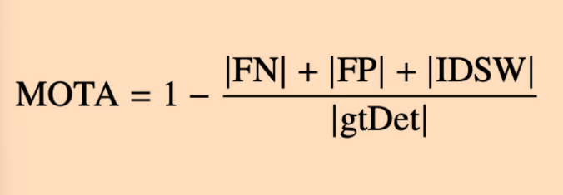

The next performance metric is the ID F1 score. IDF1 differs from MOTA in that it addresses how long the tracker correctly identifies an object, rather than just counting errors. This score measures the assignment between prediction and ground truth objects for the entire video, not just frame by frame. Below is the formula. IDTP = ID True Positive (number of correctly identified detections), IDFP = ID False Positive, IDFN = ID False Negative.

The final performance metric that is used is Higher Order Tracking Accuracy. HOTA is the most advanced performance metric as it attempts to combine detection accuracy (explain), association accuracy (explain), and localization accuracy (explain). The track errors are seen in chart below and used to calculate HOTA. These include detection errors on the left tree, association errors on the right tree, and localization errors off the main branch.
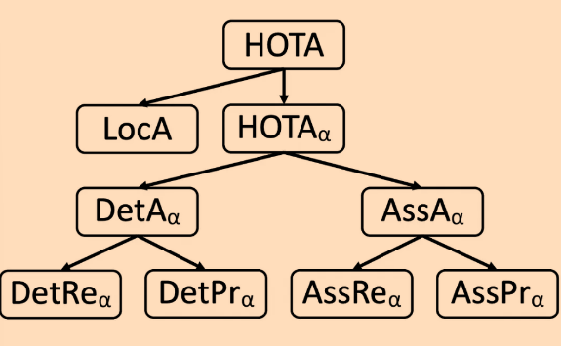

(maybe mention track-mAP, how close are the predictions to ground truth on avg)
Each performance metric is used to evaluate how well a model performs in various tracking tasks. A high MOTA score shows that the model is accurate in identifying objects correctly meaning false positives, false negatives, and identity switches are low. A high IDF1 score shows that the tracker is good at maintaining identity preservation throughout a video. Finally, a high HOTA score shows that a model can identify and track multiple objects throughout an entire video, not just frame by frame. This proves that the model is good at detection and association throughout a video.
For this project, each of these metrics will be used to evaluate how well the model detects players, maintains identity of players, and tracks multiple players throughout the videos. For CV tracker models in sports, high MOTA, IDF1, and HOTA scores are essential since proper identification, proper identity preservation, and multiple object tracking are needed to provide reliable and accurate metrics.
Goal of Project
This project is intended to explore the capabilities of CV models for sports analytics in real-time applications. CNNs, ViTs, and SWIN models each offer varying performance benchmarks within player, ball, and field landmark detections. Research and testing will determine which model shows the best performance with the necessary detections. Benchmarks will include MOTA, IDF1, and HOTA scores (maybe track-mAP) Additionally, each model’s performance will be compared to processing speed to determine relevance within applications in real-time systems.
The field of CV within sports analytics is an expanding field. Sports analysts often track player and team movements and metrics manually. The tracking of the players and teams is often seen as tedious and time intensive. Sports analysts would rather spend time interpreting and making decisions based on the collected metrics than gathering the metrics. This is because the tracked metrics are used by analysts to evaluate player performance, team dynamics, and game strategies. Within sports, these key insights are used to make large coaching decisions for performance optimization, value of players for contract decisions, and predictive modeling of outcome of games. Coaches are given valuable players and team information that help make determination on how to play the game. These decisions can lead to better or worse team performance, impacting the success of coaches and sports teams. Player valuations can be made from advanced sports metrics determining what type of contract a player may receive. This greatly impacts individual players while also impacting the entire landscape within sports contracts and negotiations.
The understanding of different CV models evaluated during this project will be a base of future capabilities of CV models within sports analytics. The use of player tracking and graphic mapping can be seen within NFL Nickelodeon broadcasts shows one potential use of these models. Below is an example use case with the NFL. This sample takes the live main broadcast and maps it into a real time cartoonish graphic for kids to watch.
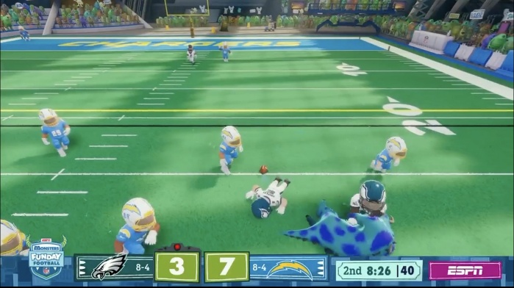

Literature Review
This section will list and summarize literature reviewed so far.
Ahmad, A. (2024, October 22). What is a vision transformer (Vit)? What are Vit’s real-world applications? This article describes what ViTs are and compares it to previously used models like CNNs. Additionally, it explains the process of how ViTs work in detail and describes some of their real-world applications like object detection.
Fujii, K. (2025, April 11). Computer vision for sports analytics. SpringerLink. This book describes how recent advancements within CV have led to increasing use within sports analytics. It describes the automation of collecting and analyzing data from sports videos. This article lays the foundation as to why CV is useful within sports analytics.
Gutiérrez-Pérez,, M., & Agudo, A. (2024, April 12). PnLCalib: Sports Field registration via points and lines optimization. This paper describes how field registration is used to work around challenges involved with varying camera angles within sports broadcasts. It describes techniques involving creating 3D soccer field models with predefined key points. This article also describes how its techniques have been used and tested on real-world soccer data sets.
Sakshi Indoliaa,*, Anil Kumar Goswamib, S. P. Mishrab, Pooja Asopaa (2018) Procedia Computer Science 132. Conceptual Understanding of Convolutional Neural Network- A Deep Learning Approach. This paper discusses the structure of CNNs and what techniques have proved optimal.
Jiang, L., Yang, Z., & Gang, L. (n.d.). Transformer-based multi-player tracking and skill recognition framework for volleyball analytics. IEEE Xplore. This paper discusses many different CV models that have been used for multi-player tracking within volleyball. It provides a helpful graphic that describes what type of CV model is used and their strengths in weaknesses. The graphic is seen below.
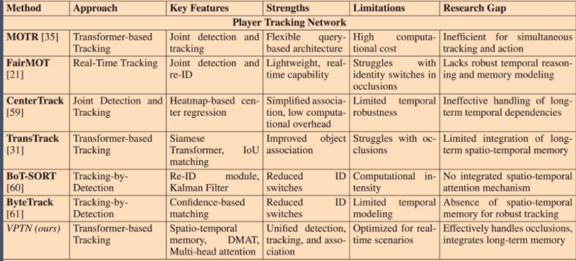

Khandelwal, R. (2022, May 11). Evaluation metrics for multiple object tracking. Medium. This article describes difference performance metrics and definitions for Multi-Object Detecting including ground truth, model prediction, error types, track-mAP, MOTA, IDF1, and HOTA. It also provided pictures of equations found throughout this document.
Mendez, M. (2024, August 25). Understanding object tracking metrics. Miguel Mendez | Personal Webpage. This article expands the previous article and offers more insights into the Multi-Object Detecting performance metrics.
Klingler, N. (2024, March 6). Mastering image registration techniques in vision. viso.ai. This article describes the overall concept of image registration which is similar to field registration. It shows different techniques of overlapping similar images from varying camera angles to represent the same scene from multiple images.
Kumari, S., Kumar, P., Verma, P., B, R., & Tripathi, S. (2024, November). Hybrid vision transformer and Convolutional neural network for sports video classification. IEEE Xplore. This article explores combining ViTs and CNNs to create sports video classification models. It describes the use of ViTs for object detection since they are versatile and scalable.
Manafifard, M., Ebadi, H., & Moghaddam, H. (2017, June). A survey on player tracking in soccer videos. Science Direct. This article describes many of the techniques that will be used throughout this project. This includes preprocessing for soccer player tracking and information about trackers that have been used in the past.
Ze Liu, et al (25 Mar 2021). Swin Transformer: Hierarchical Vision Transformer using Shifted Windows. ArXiv:2103. 14030 [cs.CV]. This paper presents a new vision Transformer, called Swin Transformer, that capably serves as a general-purpose backbone for computer vision. Challenges in adapting Transformer from language to vision arise from differences between the two domains, such as large variations in the scale of visual entities and the high resolution of pixels in images compared to words in text.
Project/App Description
The project design is intended to be a web application that creates a graphic of live player tracking for soccer sports broadcasts. The goal is to allow users to watch real time action of broadcasts without having to watch the real live broadcast. The images below show representations of sample player tracking from a broadcast and the graphic mapping representation of said player tracking broadcast. On the left, real video player tracking. On the right, graphic mapping.
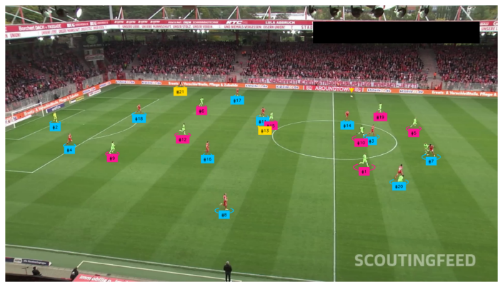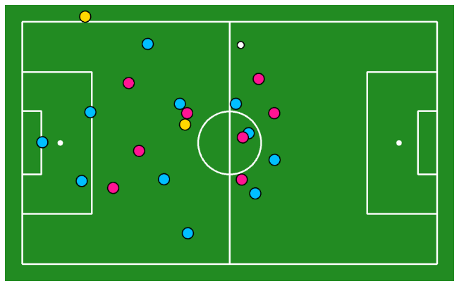
The main goal of the project will be to create an affective player tracking computer vision model that can create the graphic mapping interface. The CV model should have high performance marks making it reliable to use and process quick enough to use in a real time application. The extended goal of the project will be to create a web application for users to view live graphic mapping of different sports broadcasts.

References
Ahmad, A. (2024, October 22). What is a vision transformer (Vit)? What are Vit’s real-world applications? SJ Innovation LLC. https://sjinnovation.com/what-vision-transformer-vit-what-are-vits-real-world-applications
Fujii, K. (2025, April 11). Computer vision for sports analytics. SpringerLink. https://link.springer.com/chapter/10.1007/978-981-96-1445-5_2
Gutiérrez-Pérez,, M., & Agudo, A. (2024, April 12). PnLCalib: Sports Field registration via points and lines optimization. arXiv.org. https://arxiv.org/abs/2404.08401v4
Jiang, L., Yang, Z., & Gang, L. (n.d.). Transformer-based multi-player tracking and skill recognition framework for volleyball analytics. IEEE Xplore. https://ieeexplore.ieee.org/abstract/document/10830493
Khandelwal, R. (2022, May 11). Evaluation metrics for multiple object tracking. Medium. https://arshren.medium.com/evaluation-metrics-for-multiple-object-tracking-7b26ef23ef5f
Klingler, N. (2024, March 6). Mastering image registration techniques in vision. viso.ai. https://viso.ai/computer-vision/image-registration/
Kumari, S., Kumar, P., Verma, P., B, R., & Tripathi, S. (2024, November). Hybrid vision transformer and Convolutional neural network for sports video classification. IEEE Xplore. https://ieeexplore.ieee.org/abstract/document/10837289
Manafifard, M., Ebadi, H., & Moghaddam, H. (2017, June). A survey on player tracking in soccer videos. Science Direct. https://www.sciencedirect.com/science/article/abs/pii/S1077314217300309
Mendez, M. (2024, August 25). Understanding object tracking metrics. Miguel Mendez | Personal Webpage. https://miguel-mendez-ai.com/2024/08/25/mot-tracking-metrics

Links and descriptions of sources for personal use -
https://sjinnovation.com/what-vision-transformer-vit-what-are-vits-real-world-applications - overview of Vit vs cnn; ahmad
https://link.springer.com/chapter/10.1007/978-981-96-1445-5_2 - swin in sports; fujii
[2404.08401v4] PnLCalib: Sports Field Registration via Points and Lines Optimization – field registration; gutierrez
Mastering Image Registration Techniques in Vision – image registration aka field registration; klingler
A survey on player tracking in soccer videos - ScienceDirect; ground work of using CV models in soccer matches; ebadi
Helpful links
https://www.youtube.com/watch?v=neBZ6huolkg – long video, Build an AI/ML Football Analysis system with YOLO, OpenCV, and Python; comes with dataset
https://www.kaggle.com/datasets/iasadpanwhar/football-player-detection-yolov8 - one kaggle dataset, annotations and labels
- https://www.youtube.com/watch?v=aBVGKoNZQUw – short video
- Roboflow Sports repository: https://github.com/roboflow/sports
- 🏞️ ball, players, and referees detection dataset: https://universe.roboflow.com/roboflo...
- 🏞️ pitch keypoints detection dataset: https://universe.roboflow.com/roboflo...
- 📓 ball, players, and referees detection model training notebook: https://colab.research.google.com/git...
- 📓 pitch keypoints detection model training notebook: https://colab.research.google.com/git...
- 📓 football AI notebook: https://colab.research.google.com/git...
- ⚽ Ball Tracking in Sports with Computer Vision blog post: https://blog.roboflow.com/tracking-ba...
- ⚽ Camera Calibration in Sports with Keypoints blog post: https://blog.roboflow.com/camera-cali...
football-ai.ipynb - Colab – step by step of tracking to plotting on digital pitch; need digital pitch part. Could use different tracking models however
https://github.com/roboflow/rf-detr - roblow flow detr
https://ieeexplore.ieee.org/abstract/document/10837289 - Vit and CNN combined in sports
https://ieeexplore.ieee.org/abstract/document/10830493 - player tracking with cnn(yolo) action recognition with Vit in volleyball
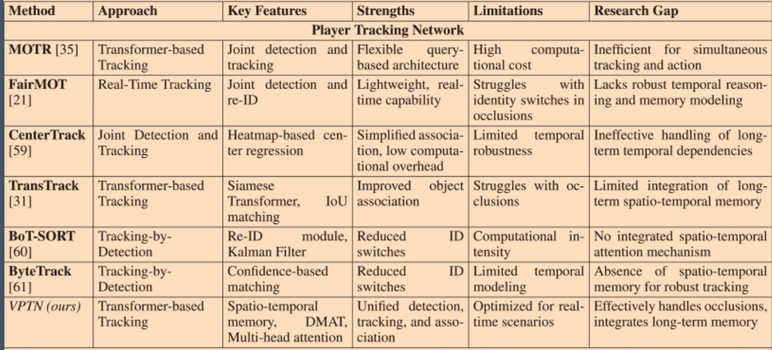
🔍 1. High-Level Summaries
FairMOT
- Full name: Fair Multi-Object Tracking
- Year: 2021
- Core idea: Joint detection and Re-ID with a centroid-aware, anchor-free network that balances detection quality and tracking identity features.
- Architecture: Single network with a shared backbone; predicts both object locations and Re-ID embeddings.
Best for: Strong baseline tracking with simple integration and robust ID consistency.

TransTrack
- Core idea: Use transformers to link current detections with previous frame features, instead of greedy matching (like Hungarian).
- Approach: Detection + transformer-based data association in one pipeline; learns to match across time with attention.
Best for: Scenarios where long-range temporal context boosts association (occlusions, fast motion).

MOTR
- Full name: Multi-Object Tracking with Track Transformers
- Core idea: Formulates tracking as a pure sequence modeling problem — no separate tracker component.
- Architecture: Transformer tracks as queries that evolve over time (similar to object queries in DETR).
- Unique: Explicit track query propagation across frames.
Best for: End-to-end learning of detection and tracking with strong long-term temporal modeling.

🧠 2. Methodologies Compared
Aspect | FairMOT | TransTrack | MOTR
Tracking Paradigm | Detection + Re-ID + matching | Detection + Transformer matching | Pure Transformer track queries
Core Matching Mechanism | Embedding similarity + Hungarian | Attention between frames | Transformer propagation of tracks
End-to-End Training | Partially (detection & Re-ID) | Yes (joint det + assoc) | Yes (tracking fully integrated)
Backbone | CNN (e.g., DLA) | CNN + transformer module | CNN + transformer
Temporal Context | Per-frame features + embeddings | Self- & cross-attention across frames | Track query propagation
Memory of Past Tracks | Embedding buffer | Attention memory | Transformer track queries

🚀 3. Strengths & Weaknesses
🟢 FairMOT
Strengths
- Well-balanced between detection quality and ID embedding discriminability.
- Easier to train and tune compared to transformer-heavy models.
- Good FPS and practical for real-time to near-real-time inference.
Weaknesses
- Re-ID only uses single-frame features; limited temporal reasoning.
- Struggles more with heavy occlusions or rapid object motion without explicit temporal modeling.

🟣 TransTrack
Strengths
- Uses cross-frame attention to directly learn associations.
- Better handling of occlusions & appearance changes via learned matching.
Weaknesses
- Transformer parts increase computational cost.
- More complex training and hyperparameters than FairMOT.

🔵 MOTR
Strengths
- Clean end-to-end: track queries are the tracker.
- Long temporal context naturally via transformer propagation; great for reappearance after occlusion.
- No hand-crafted matching (e.g., Hungarian) needed.
Weaknesses
- High computation and memory (transformer scaling).
- More challenging training schedules.
- Often lower real-time throughput compared to simpler baselines.

📊 4. Typical Performance Trends
Note: Numbers vary by dataset (MOT17, MOT20, DanceTrack), detector backbones, and training strategies — this is about relative trends, not exact scores.
📌 Metrics of Interest
- MOTA: Detection + association quality.
- IDF1: Identity preservation in tracks.
- FP / FN: False positives/negatives.
- IDs: ID switches.
Model | MOTA | IDF1 | IDs | Speed
FairMOT | 👍 Solid | 👍 Good | 👍 Moderate | 🚀 Best
TransTrack | 👍 Good | 👍 Better | 👍 Better | ⚡ Moderate
MOTR | ⭐ Best IDF1 / ID handling | ⭐ Best long temporal consistency | 🔽 Fewest ID switches | 🐢 Slowest
👉 FairMOT: balanced performance
👉 TransTrack: better temporal matching
👉 MOTR: best for identity stability but heavier

🧩 5. When to Choose What
👉 Choose FairMOT if:
✔ You want strong baseline tracking quickly
✔ You need good throughput (near real-time)
✔ You prefer a simpler training pipeline

👉 Choose TransTrack if:
✔ You want detector + association learned jointly
✔ Occlusion and inter-frame matching are challenging
✔ You’re okay trading speed for robustness

👉 Choose MOTR if:
✔ You want cutting-edge tracking quality
✔ Tracking continuity and identity retention matter most
✔ You can afford GPU compute and training complexity

🧠 Quick Intuition Summary
- FairMOT: Smart detection + Re-ID embeddings + standard matching.
- TransTrack: Transformer learns matching across frames.
- MOTR: Tracks are queries that evolve through time — tracking is baked into the network.
Option 1: CNN-based models (YOLO, FairMOT, ByteTrack, StrongSORT)
✅ Why CNNs dominate real-time soccer
- Extremely fast and well-optimized
- Excellent local feature extraction (jerseys, limbs, ball)
- Huge ecosystem (YOLOv8/v9, TensorRT, ONNX)
- Easy to combine with:
  - Kalman filters
  - Motion models
  - Field registration (homography)
Typical pipeline
CNN Detector (YOLO)
→ Tracker (ByteTrack / FairMOT / StrongSORT)
→ Optional Re-ID embeddings
→ Optional field registration
Pros
✔ 30–120 FPS on a single GPU
✔ Stable IDs with good Re-ID
✔ Works well with broadcast footage
✔ Production-proven in sports analytics
Cons
✖ Limited global context
✖ Occlusion handling relies on heuristics
✖ Long-term identity recovery is weaker
👉 Best choice if you need reliable real-time today

Option 2: Vision Transformers (ViT, MOTR, TransTrack)
What ViTs do better
- Global spatial reasoning
- Temporal attention across frames
- Better identity persistence through occlusions
Why they struggle in real-time soccer
- Quadratic attention cost
- Slower inference
- Harder deployment (less TensorRT-friendly)
Example models
- MOTR
- TransTrack
- Soccer-specific transformers (ASTRA, Action Spotting Transformers)
Pros
✔ Fewer ID switches
✔ Better occlusion recovery
✔ Cleaner end-to-end tracking logic
Cons
✖ Often <15–20 FPS
✖ Heavy GPU memory usage
✖ Training complexity
👉 Best for offline analysis or semi-real-time

Option 3: Swin Transformer (the middle ground 🧠⚡)
Swin is not a full ViT — it’s hierarchical and windowed.
Why Swin works better for soccer
- Local attention → lower compute
- Still captures global structure across layers
- Plays nicely with detection frameworks (DETR variants)
Pros
✔ Better global context than CNN
✔ Much faster than vanilla ViT
✔ Good with moving cameras & formations
Cons
✖ Still slower than CNN
✖ Harder to optimize than YOLO
✖ Limited mobile / edge deployment
👉 Best “hybrid” choice if you want smarter tracking but still real-time-ish

🔥 Practical Recommendation (Most Teams Use This)
🥇 Best real-time choice
CNN detector + lightweight tracking
- YOLOv8 / YOLO-NAS
- ByteTrack or FairMOT
- Optional Re-ID head
- Optional homography field alignment
This gets you:
- 30–60 FPS
- Stable tracking
- Easy deployment
- Production reliability

🥈 Best accuracy–speed balance
CNN backbone + Swin / Transformer head
- CNN for detection
- Transformer for association
- Reduced attention scope

🥉 Best tracking quality (not fully real-time)
Full Transformer (MOTR / TransTrack)
- Offline analytics
- Tactical analysis
- Player re-identification across halves

https://arshren.medium.com/evaluation-metrics-for-multiple-object-tracking-7b26ef23ef5f - multi object detection performance metrics
Understanding Object Tracking Metrics - performance metrics again

